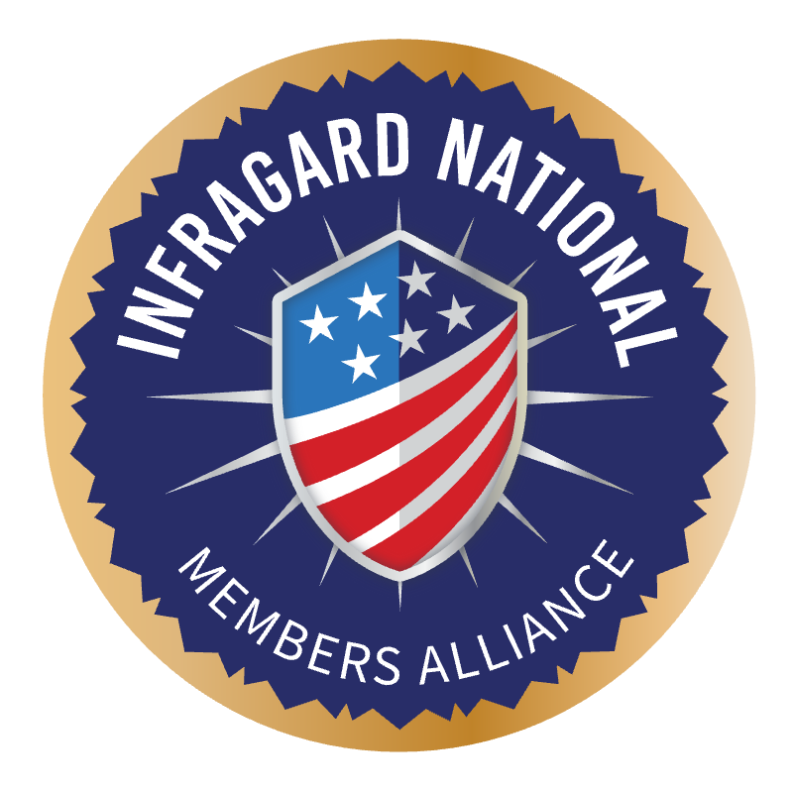

InfraGard National Members Alliance

2026 Board of Directors Nomination Packet

Section 1: Nomination and Election Information and Process

Per the Bylaws of the InfraGard National Members Alliance (INMA), as amended 2016, each year two (2) seats on the INMA Board of Directors are up for election. The election occurs during the annual InfraGard Congress. Newly elected board members will be qualified at the first official board meeting following Congress, pursuant to the INMA Bylaws (Article V, Sections III and VIII). These board members will serve a three (3) year term from the date of the first official in-person board meeting until their successor is in place.

Nominate members in one of the following two ways:

- IMA Nominations - Each InfraGard Members Alliance (IMA) may nominate one (1) candidate for the Board of Directors;

- Petition Nominations – A member of InfraGard may be nominated (without an IMA nomination) by presenting a petition with the signatures of at least twenty (20) InfraGard members in good standing.

- Nominations Submission Deadline: Completed Nominations Application Packet must be submitted to the INMA Secretary, secretary@infragardnational.org, and the INMA Nominations Chair, nominationchair@infragardnational.org by 5:00 pm EST on Tuesday, August 11, 2026. The completed Nomination Application packet must be received by the INMA Secretary, regardless of when it was sent, on or before this deadline.

There are EIGHT (8) Sections to this Nomination Application Packet:
- Section 1: Nomination and Election Information and Process (Above)
- Section 2: Board of Directors Nomination by an InfraGard Members Alliance (IMA)
- Section 3: Board of Directors Nomination by Petition
- Section 4: Questions about Your Service to InfraGard and Curriculum Vitae
- Section 5: Board of Directors Nominee Commitment Agreement
- Section 6: Board of Directors Conflict of Interest Disclosure
- Section 7: Board of Directors Attributes and Responsibilities
- Section 8: Board of Directors Nomination Application Checklist

ONLY FULLY COMPLETED NOMINATIONS APPLICATION PACKETS ARE ACCEPTED. The Nominations Committee will review packets upon receipt to ensure they are complete. During the time following the nomination window closure, the Nominations Committee will validate each packet. If a Nominations Application Packet is missing any required information, a Nominations Committee member will reach out to each nominee for the missing information. Each nominee is allowed THREE BUSINESS DAYS to respond with the missing information. If the missing information is not received within the THREE-BUSINESS DAY window, the nomination application WILL NOT BE ACCEPTED. The Nominee and the nominating IMA president will be notified via email from the Nomination Committee Chair on the fourth business day of his or her removal as a nominee. Nominees whose Nomination Application Packet is declined are always welcome to run again in any following Board of Directors elections.

Section 2: Board of Directors Nomination by an InfraGard Members Alliance (IMA) and

Section 3: 2026 Board of Directors Nomination by Petition refer to the method by which a nominee can be nominated. ‘IMA-Nominated’ refers to when an IMA President nominates one of its members in good standing for an INMA Board of Directors position. The Petition Nomination is when an IMA member in good standing nominates himself or herself and is not nominated by an IMA. Either Section 2 or Section 3 must accompany the Nominations Application Packet.

Section 4: Questions about Your Service to InfraGard and Curriculum Vitae. The Nominations Application Packet includes questions for each Nominee to answer regarding her/his understanding of InfraGard at both the local and national level and the professional experience and skills she/he offers to the InfraGard community. As part of the Nominations Application Packet, a copy of your curriculum vitae (i.e., resume) is required. A copy of each Nominee’s responses to the questions and curriculum vitae will be available to the IMAs prior to Congress to assist the IMAs in their voting decisions.

Section 5: Board of Directors Nominee Commitment Agreement. To ensure that all potential Board of Director Members understand the expectations and commitment level required in being a member of the INMA Board of Directors, Nominees must sign and return a commitment letter in the form attached as a requirement for being accepted as a nominee.

Section 6: Board of Directors Conflict of Interest Disclosure. Each Nominee must sign and return the Conflict of Interest Disclosure Statement with the Nomination Application Packet. This document certifies that no potential conflicts exist for a Nominee to hold a position on the INMA Board of Directors.

Section 7: Board of Directors Member Attributes and Responsibilities. Included on the last page of the Nomination packet is a summary of desired Board of Director attributes and responsibilities that match the needs of INMA and the InfraGard program. Board of Director Members should expect to spend approximately twenty (20) hours per month serving at the national level in addition to any commitments they may have at the local level.

Section 8: Board of Directors Nomination Application Checklist: This checklist will help you complete this Nomination Application Packet, ensuring completeness prior to submission. Incomplete Nomination Application Packets will be declined; make sure to check it carefully.

During the InfraGard Congress on Sunday, September 27, 2026, and prior to the vote, each Nominee will be given five (5) minutes to introduce herself/himself to the Delegates and briefly describe her/his reasons for running for the Board of Directors.

Section 2: Board of Directors Nomination by an InfraGard Members Alliance (IMA)

To be completed by an IMA nominating a candidate.

The InfraGard Members Alliance hereby nominates

for the 2026 InfraGard National Members Alliance Board of Directors election.

Nominee Name: IMA: Title / IMA Position(s):
Employer:
Phone:
E-mail:

Authorized IMA Representative (printed name)

Authorized IMA Representative Signature

Date:

Title (IMA Position): Phone:
E-mail:

To be completed by the Nominating IMA’s FBI Private Sector Coordinator (PSC):

I confirm that the above-named Nominee,
is an InfraGard member in good standing.

Signature of FBI PSC

Printed Name of FBI PSC

Date:

Section 3: Board of Directors Nomination by Petition

To be completed by a nominee who is not submitted by an IMA. (This form is not required for an IMA nominee).

The undersigned twenty (20) members of InfraGard hereby nominate:

for the 2026 InfraGard National Members Alliance Board of Directors election.

IMA:
Title (IMA Position):
Employer:
Phone:
E-mail:
InfraGard members in good standing who support this petition:

Printed Name: Signature:
1.
2.
3.
4.
5.
6.
7.
8.
9.

10.
11.
12.
13.
14.
15.
16.
17.
18.
19.
20.

To be completed by the FBI PSC for the IMA in which the Nominee is a member:

I confirm that the above-named Nominee, __________________________________________
is an InfraGard member in good standing.

___________________________________________________________________________
Signature of FBI PSC

____________________________________________________________________________
Printed Name of FBI PSC

Date: _______________________________________________________________________

Section 4: Questions about Your Service to InfraGard and Curriculum Vitae

To be completed by all Nominees
Nominee Name:

Nominee’s IMA:

LIMIT YOUR AGGREGATE RESPONSE TO 1,000 WORDS. The Nominations Committee will truncate responses exceeding 1,000 words. Do not embed images or HTML links. If needed, attach additional sheet(s).

- How long have you been an InfraGard member and what has been your level of participation?

- Why are you interested in serving on the INMA Board of Directors, and why do you feel you are a good candidate? What contributions do you believe you can make to the organization?

- Give an example of a time when you held a leadership role that would directly relate to serving in a similar capacity with INMA. What were some accomplishments that resulted from your leadership?

- Briefly describe a large-scale personal or professional initiative or program you have taken on in the past. How has that experience shaped you as a potential INMA Board Member?

- As a national public/private partnership with 45,000+ members, what particular opportunity do you see as most important to the success of InfraGard? What impact can you have on that opportunity if elected?

- From your perspective, what is the greatest challenge facing local IMAs? And what is the greatest challenge facing INMA as a national organization? How would you address these challenges?

Section 5: Board of Directors Nominee Commitment Agreement

To be completed by all Nominees

Nominee Name:
IMA:
Title (IMA Position):
Employer:
Phone:
E-mail:

I, , understand and agree that:
- I am running for a three (3) year term starting from the date of the first official in-person board meeting and pursuant to the INMA Bylaws;
- Service on the InfraGard National Members Alliance Board of Directors involves a substantial commitment of time (approximately twenty (20) hours per month);
- I have the scheduling flexibility required to travel to and attend board meetings several times a year at various locations around the United States, participate in INMA Board virtual board meetings and conference calls every month, and am available to conduct InfraGard business during regular business hours; and
- I understand that INMA is an FBI-affiliated independent nonprofit organization that represents the private sector component of the FBI’s InfraGard program, and that Board Members cannot use InfraGard, affiliation with InfraGard, or their position on the INMA Board of Directors for financial gain or advertising purposes.
- As an InfraGard member, I agree to abide by the InfraGard Code of Conduct and understand that not doing so may result in the revocation of my membership in InfraGard.

My signature hereunder indicates only that I acknowledge receipt of this document and at the time of signing believe that the information contained herein is true and accurate to the best of my knowledge. My signature does not constitute nor imply any further agreement to which my Company or I is a party.

Printed Name of Nominee:

Signature of Nominee:

Date:

Section 6: Board of Directors Conflict Of Interest Disclosure

All Board of Directors Nominees must complete this form as required by Article V, Section 3, of the INMA Bylaws. In particular, this section requires:

- That in order to serve as a Director of the Corporation, the candidate must be an individual Member in good standing of InfraGard;
- That the Board may not include more than one person from any single corporation or family;
- That no one may serve on the INMA Board and as an IMA corporate officer, or voting delegate of an IMA concurrently; and
- Board Members and Nominees to the Board will disclose any and all professional, corporate or personal, contacts or relationships that may present a conflict of interest or otherwise might impede the member’s ability to serve on the Board in an objective manner.¹

ACCORDINGLY, PLEASE ANSWER ALL OF THE QUESTIONS BELOW:

  - Are you in compliance with criteria A-D as stated above? Y/N

  - Do you presently have a professional relationship1 with any member of any IMA Board? Y/N

  - Do you presently have a professional relationship with any member of the INMA Board? Y/N

  - Do you presently have a professional relationship with any employee of the FBI? Y/N

  - Do you presently have a professional relationship with any employee of any government partner of the INMA? Y/N

  - Are you presently employed by an entity that does significant business2 with any IMA? Y/N

  - Are you presently employed by an entity that does any business with the INMA? Y/N

  - Are you presently employed by an entity that does significant business with the FBI? Y/N

  - Are you presently employed by an entity that does significant business with any government partners of the INMA? Y/N

  - Are you presently employed by, or have any economic interest in, an entity that might compete with the goals and objectives of the INMA or its government partners? Y/N

  - Do you have any further conflicts to disclose in order to meet your obligation stated in criteria “D” not already covered by one of the previous questions? Y/N

1 “…professional, corporate or personal, contacts or relationships” will be defined as: “relationships that result in a significant economic interest existing between the parties”. 2 Significant Business will be defined as: a business relationship where more than 10% of either entities revenue is directly dependent on the other.

Explain and clarify any “Y” (yes) answers to the above questions, indicating which question you are responding to. If needed, attach additional sheet(s).

I affirm, to the best of my ability, that the answers I have given are truthful and complete.
Further, I understand that it is my responsibility to update this Disclosure Form if any of the information contained herein changes during my service on the INMA Board of Directors.

Printed Name:

Signature:

Date:

Section 7: Board of Directors Member Attributes

Desired attributes:
- Previous board experience (corporate, academic or non-profit)
- Extensive professional/work experience in the public or private sectors, relevant to the
execution of the INMA and InfraGard missions.
- A willingness to commit, as well as have sufficient time available, to discharge the
duties of board membership.
- Leadership experience
- Management experience
- Fundraising experience
- Integrity, professionalism, and high ethical standards
- Good interpersonal, communications and diplomacy skills
- A network of strong relationships in both the public and private sectors
- Negotiation experience
- Superior organizational skills
- Excellent time management/efficiency
- Media/public relations experience and media training
- Effective public speaking skills
- Writing and editing skills
- Trusted nationwide reputation

Responsibilities:
- Contribute to INMA’s vision and mission, culture, strategic planning, financial sustainability, and effectiveness.
- Provide oversight and governance of INMA and the IMAs.
- Duty of Care - ensure prudent use of INMA assets, including people, finances, brand equity, and goodwill.
- Duty of Loyalty – ensure that INMA’s activities are first and foremost advancing its mission, and make decisions that are in the best interests of INMA.
- Duty of Obedience - ensure that INMA obeys applicable laws and regulations, follows its bylaws, and adheres to its stated purposes and mission.
- Fundraising - help identify and pursue INMA funding sources such as corporate sponsors and grants.
- Serve on INMA committees and take on special assignments as needed.
- Take an active role in the identification planning, management, and execution of programs, projects, and events that will advance the INMA mission.
- Provide oversight for INMA programs.
- Attend monthly INMA board meetings both virtually (second Tuesday of the month from 10 a.m. – 12 p.m. Pacific time) and in-person (quarterly).
- Attend the INMA board’s annual strategic planning meeting.
- Attend INMA meetings and events.
- Communicate with, and serve as a resource for, InfraGard members and IMA leaders nationwide.
- Work directly with INMA partners and public and private sector leaders.
- Represent INMA and the InfraGard program in a manner that enhances public standing among stakeholders including membership, government, press, partners and more.

Section 8: Board of Directors Nomination Application Checklist

This checklist will help you complete this Nomination Application Packet, ensuring completeness prior to submission. Incomplete Nomination Application Packets will be declined, so please review your packet carefully.

Step | Action | Complete
1 | Determine if you will be nominated by your IMA, or if you will be a Petition Nomination
2 | Section 2: Board of Directors Nomination by an InfraGard Members Alliance (IMA)
3 | Section 2 includes IMA representative’s signature
4 | Section 2 includes FBI PSC’s signature
5 | Section 3: 2026 Board of Directors Nomination by Petition
6 | Section 3: Petition Nominations must include a list of 20 signatures of 20 members in good standing
7 | Section 3 includes FBI PSC’s signature.
8 | Section 4: Questions about Your Service to InfraGard and Curriculum Vitae
9 | Section 4: All questions are answered and the aggregate response is limited to a total of 1,000 words
10 | Section 4 Curriculum Vitae or Resume is current and included
11 | Section 5: Board of Directors Nominee Commitment Agreement is completed and signed
12 | Section 6: Board of Directors Conflict of Interest Disclosure Statement is completed, signed and dated. All 11 questions are answered either Y or N; any explanation for Y answers are included
13 | Section 7: Board of Director Member Attributes and Responsibilities are reviewed and understood
14 | Section 8: Board of Directors Nomination Application Checklist is complete
15 | Nominations Application Packet and all attachments received by NominationChair@infragardnational.org & Secretary@infragardnational.org by the deadline of Tuesday, August 11, 2026. The completed Nomination Application packet must be received by the INMA Secretary and Nominations Chair, regardless of when it was sent, on or before this deadline.

